# **How to Make a Camera Follow the Object Movement**

**Step 1:-** Open Unity, right-click on **Hierarchy** menu > **3D Object** > **Cube**.

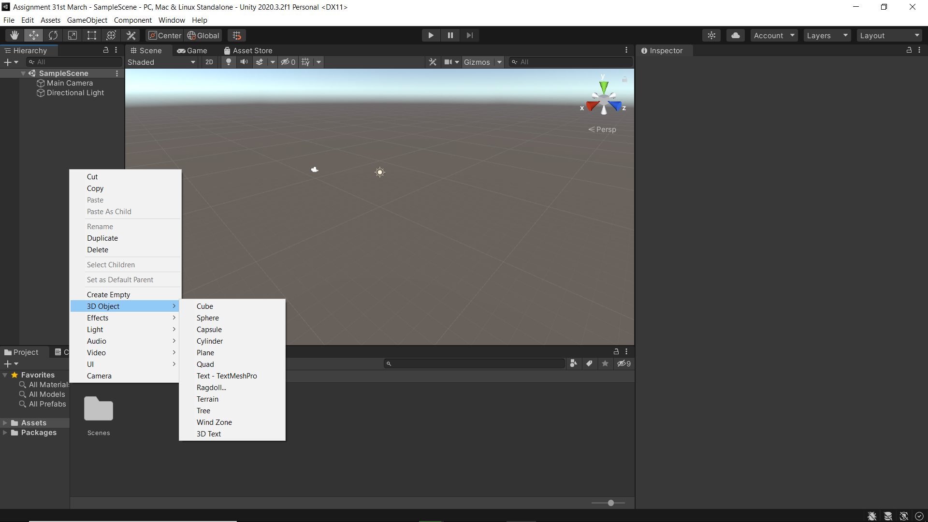

A cube will be inserted.

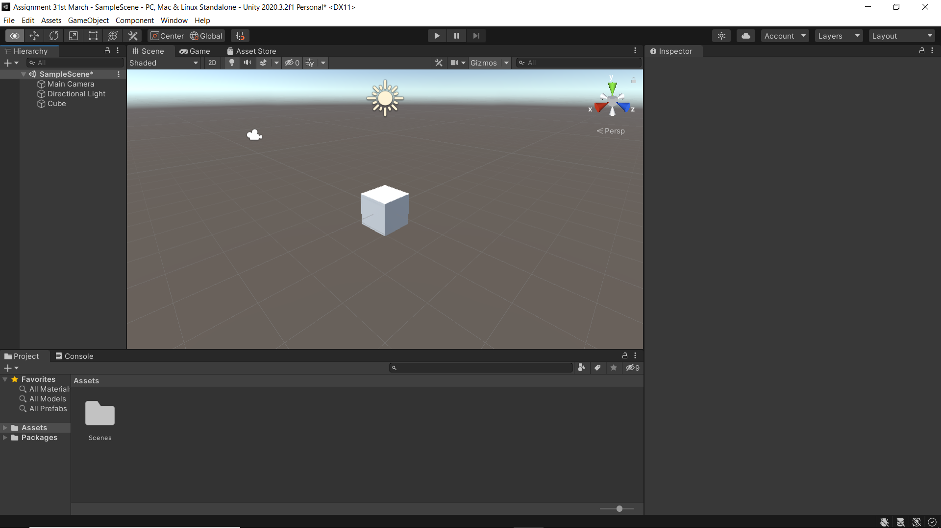

**Step 2:-** Deform the cube’s shape and make a platform out of it using **Scale Tool** and make 2 more copies of the same cube.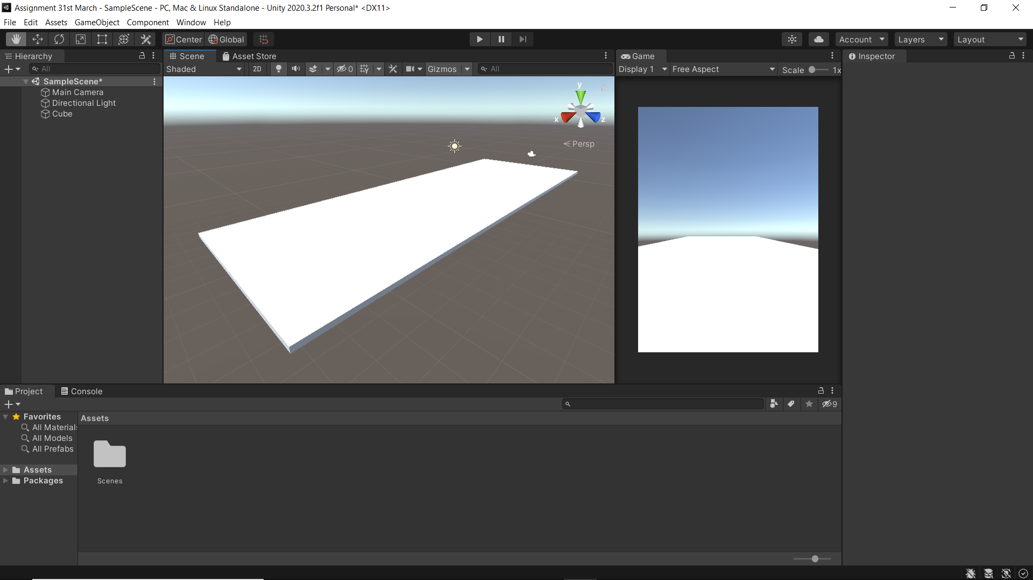

**Step 3:-** After copy-pasting the cubes, arrange them using **Move Tool, Scale Tool** and **Rotate Tool** in such a way, that they resemble a slanted platform.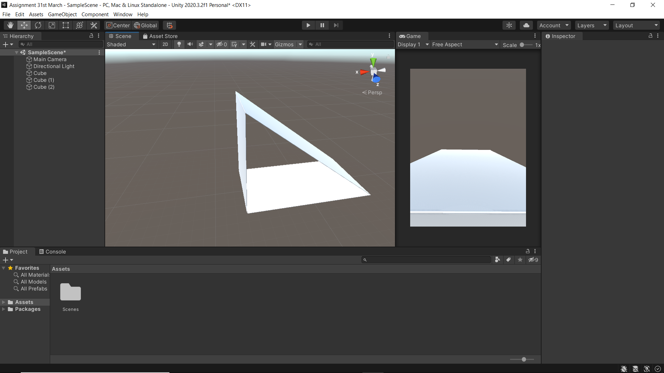

**Step 4:-** Now, add a sphere with the same steps as adding the cube and place it on top of the slope.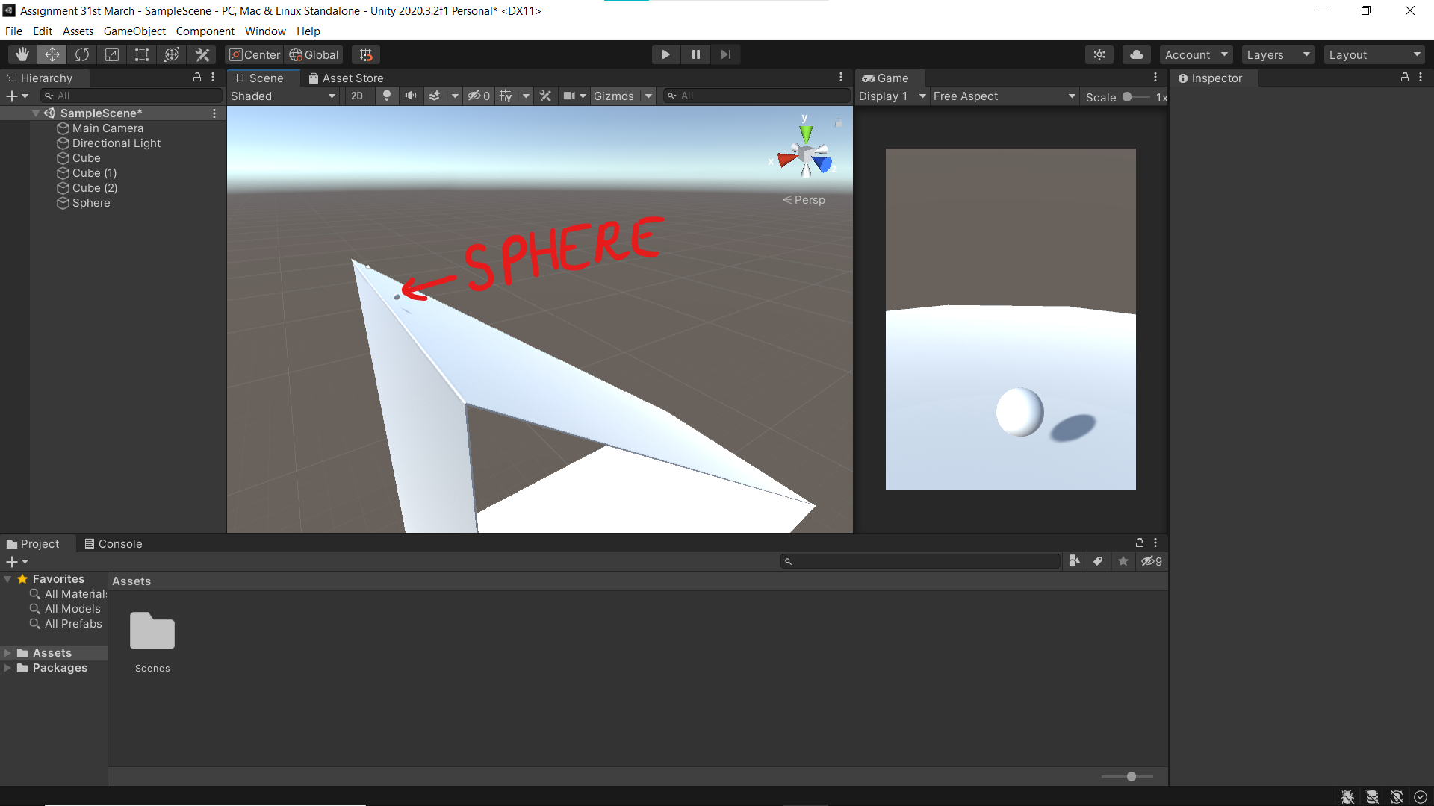

**Step 5:-** Select the sphere, rename it to “player”. under **Inspector** tab, click **Add Component** > **Physics** > **Rigidbody**. **Rigidbody** adds physics of a solid body to the GameObject. 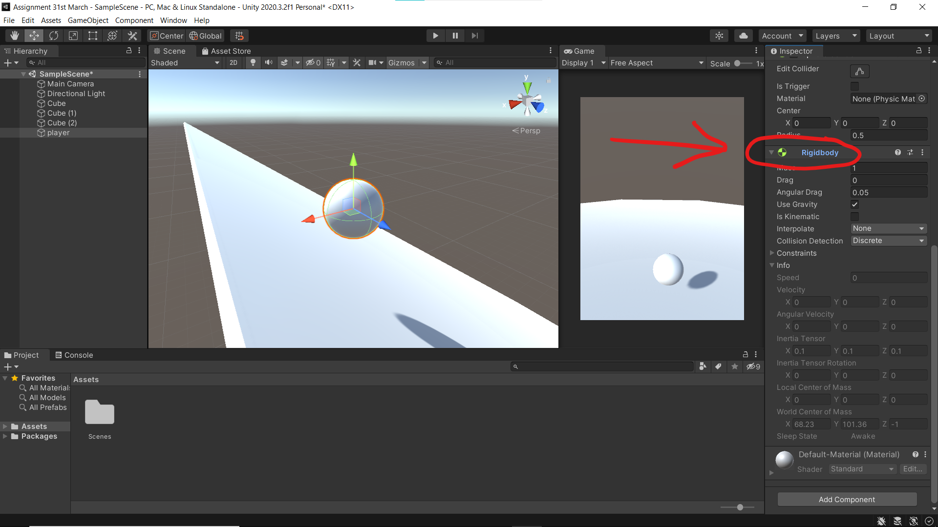

**Step 6:-** Right-click inside **Properties** tab > **Create** > **Material**. Select a desired color and drag-and-drop the material on the player.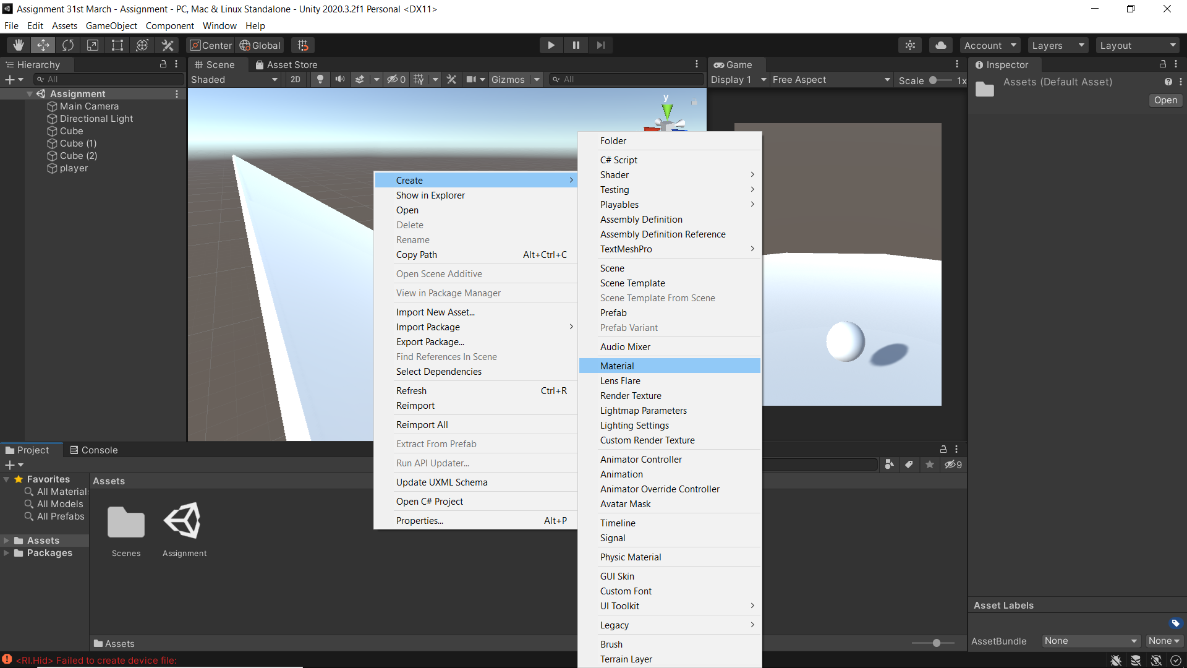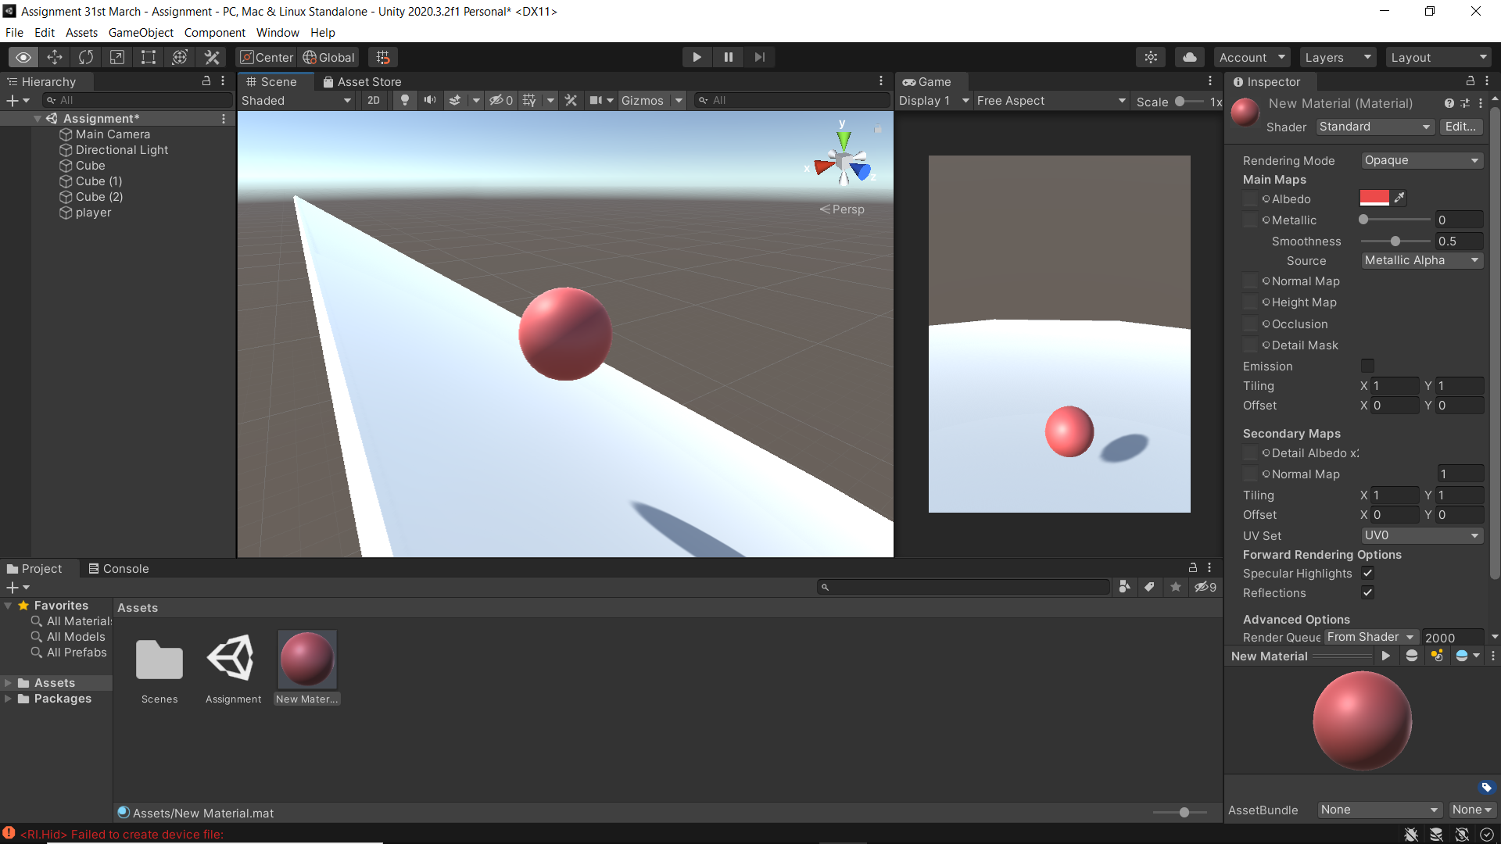

**Step 7:-** Under **Inspector** tab, click **Add Component** > **New Script** > rename as “Player Movement”. Double-click the script then Visual Studio Code will open.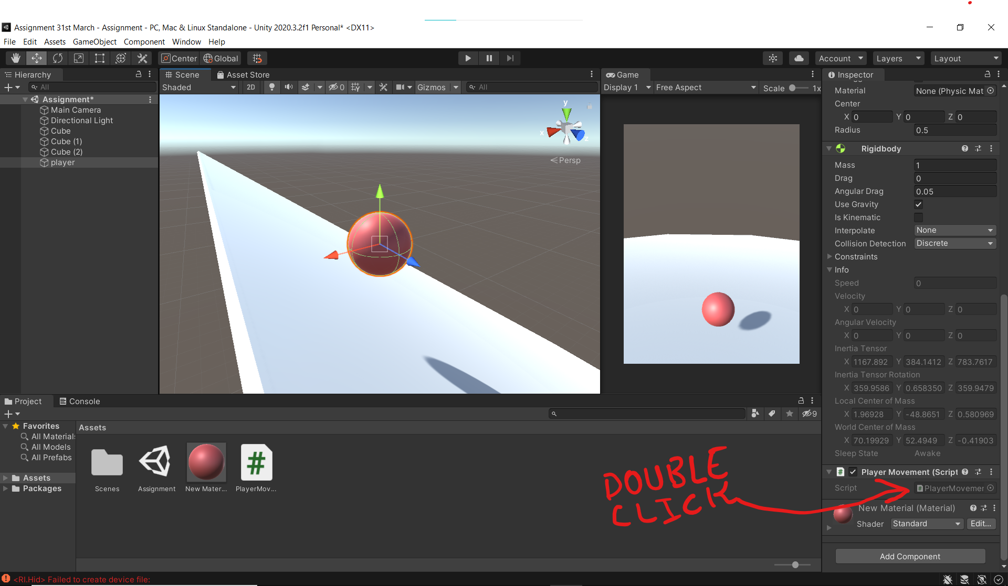

**Step 8:-** Write the following code for adding movement and desired velocity to the player in the PlayerName script.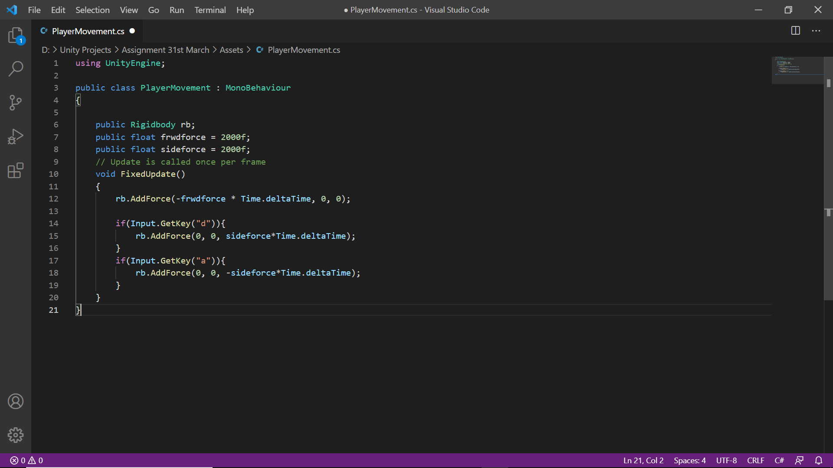

**Step 9:-** Save the script and it will be automatically updated in Unity. Drag the “player” GameObject to “rb” variable.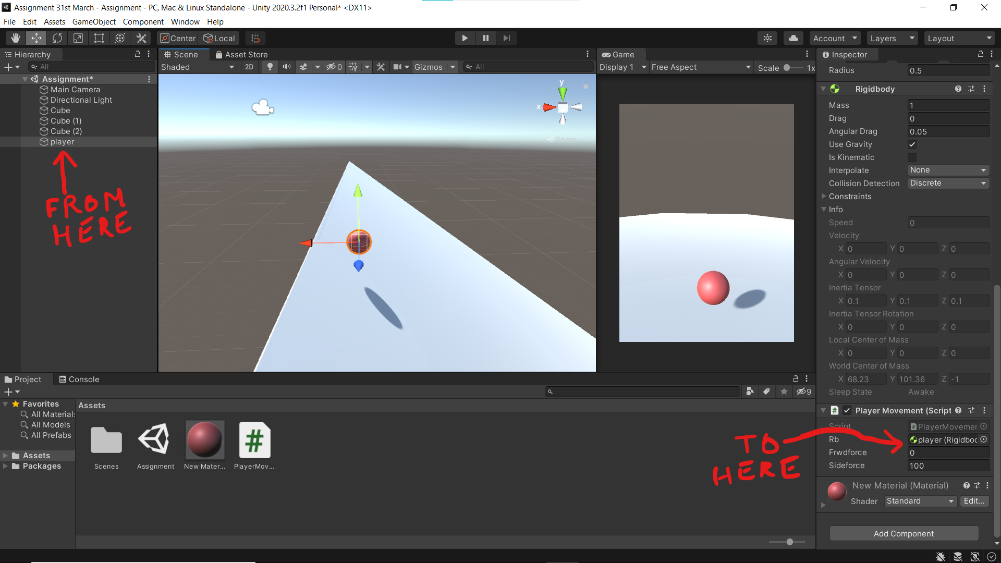

**Step 10:-** Select **Main Camera** and add a new script to it called “FollowPlayer” and add the following code to the script and drag “player” GameObject to “player” variable.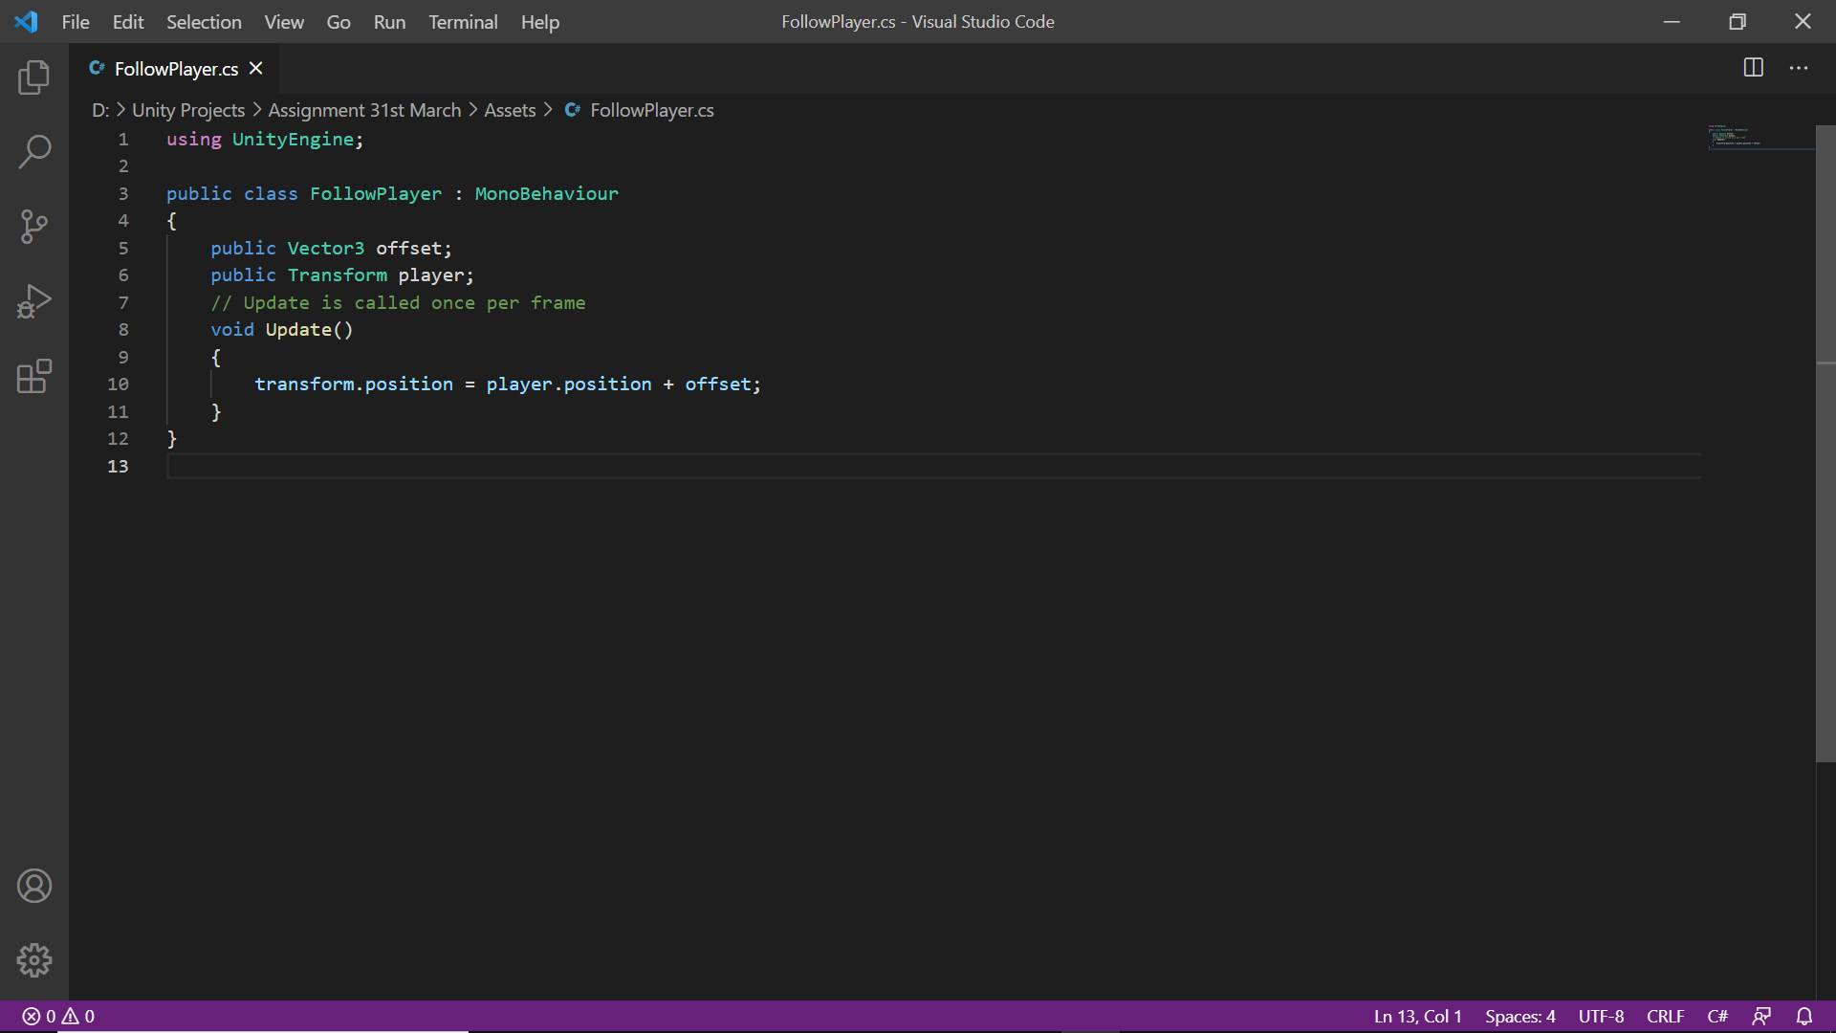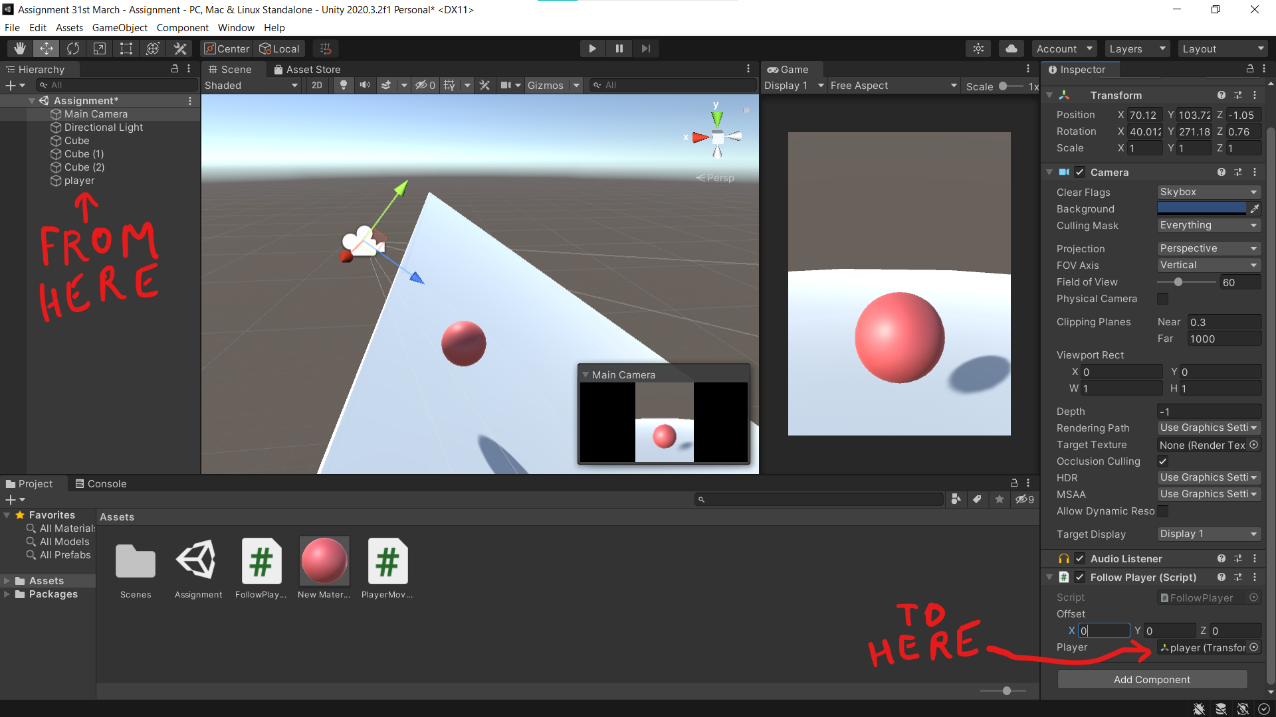

**Step 11:-** Enter the Offsets as desired. Here, they are (X,Y,Z) = (4,4,0).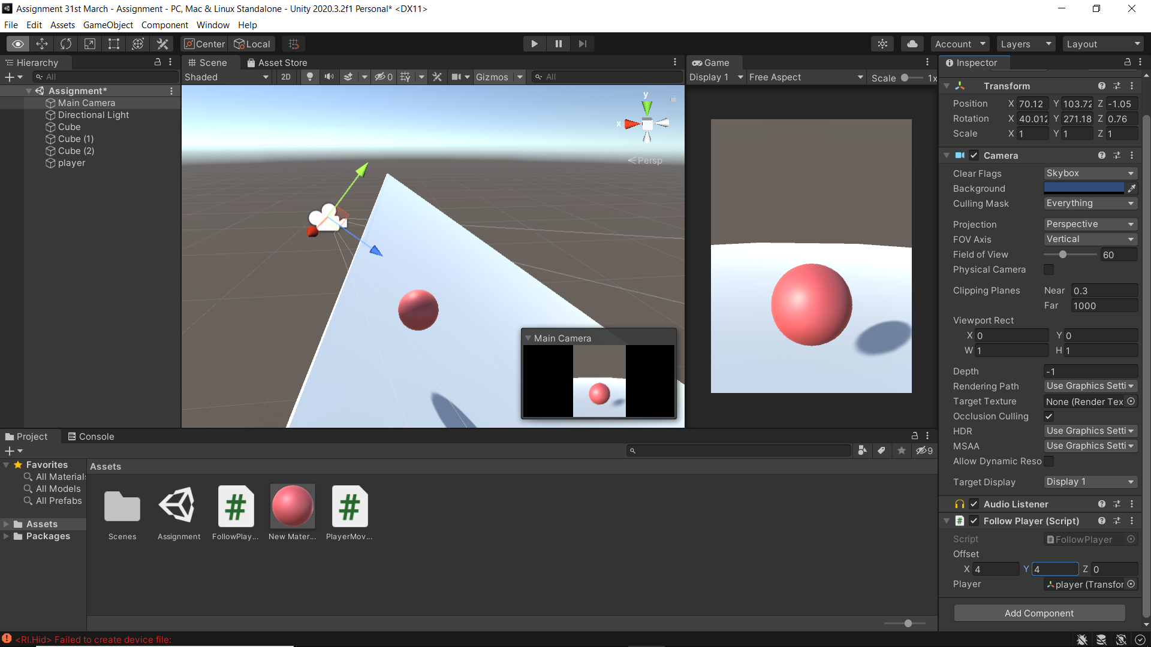**Step 12:-** Now, to check the final product, press the play button at the top-centre of the screen. 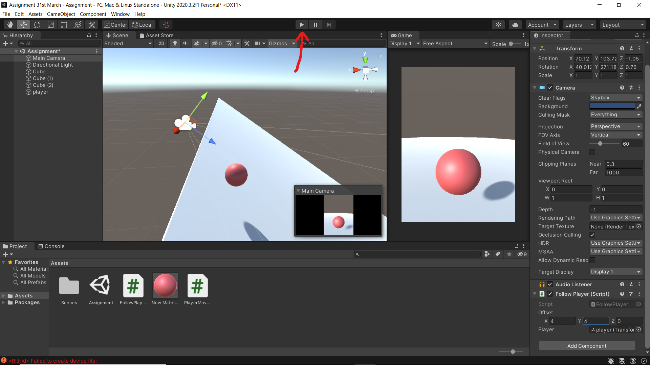

**Note:-**  To make the project more appealing, we can add random shapes through the same procedure as obstacles.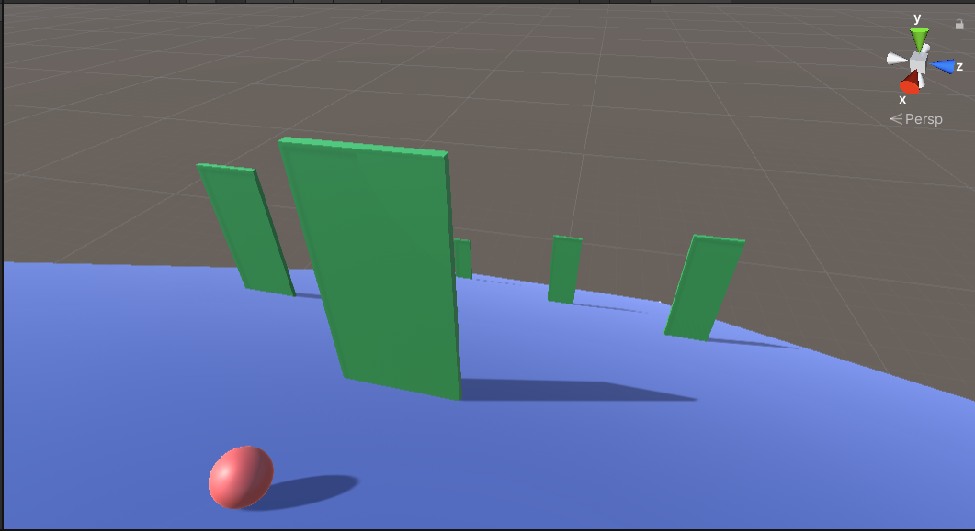

**Preview:-**

